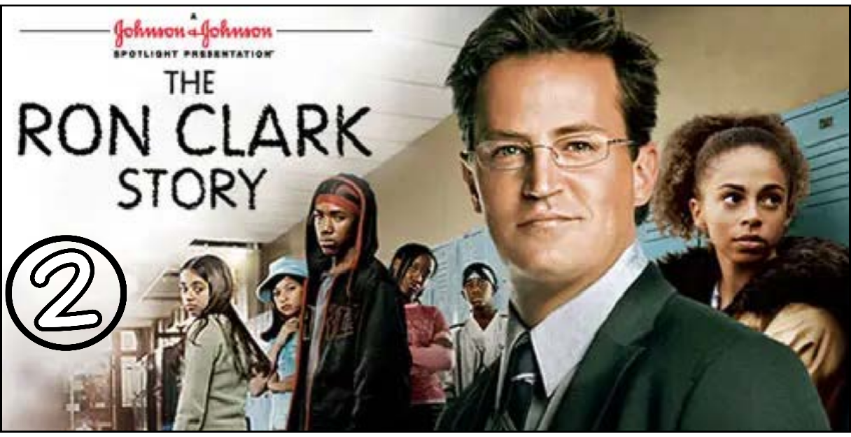
“The Ron Clark Story” (Scene 02)

Part 01 / Work on the Scene

- Scene summary: (each student must participate / ONE BY ONE)

“The scene begins with Clark at the motel, asking Yolanda for a list of public schools in Harlem. He then starts searching for a new job. Day after day, moving from one school to another, he fails to get hired.
One day, just as he is about to enter a school, a teacher and a student rush out, quarreling loudly. Clark immediately steps in and stops the fight. When the principal arrives, the teacher announces that he is quitting.
Clark seizes the opportunity and convinces the principal to hire him. The principal offers him a third-grade class, but Clark chooses a different class that seems to have many problems. Before he begins teaching, Clark decides to meet the students’ parents.
”

- Scene Discussion & Analysis: (All the group participate at once)

- Q01: What does Mr. Clark do for a living?
He is a teacher.
- Q02: Did he find a job quickly in Harlem?
No, he didn’t.
- Q03: What is your impression of this city “Harlem”?
In my opinion, Harlem is a very big modern crowded city.
- Q04: In your opinion ... Mr. Clark was a highly respected teacher back in North Carolina. Why did he want to move to New York where nobody knows him?
Clark moved to New York because he hadn’t been a permanent teacher in North Carolina for four years, so he decided to take his chance in another place.
- Q05: Mr. Clark eventually found a job at Inner Harlem Elementary School. What is your impression on the school and the class he is going to teach?
Overall, the school is good, except for the special class that has many problems.
Q06: Did Mr. Clark start teaching immediately?
No, he didn’t.
- Q07: If not, what did he prefer to do before he started teaching?
He prefers to meet the students’ parents.

Part 02 / Acquired vocabulary & Grammar from the scene

- Acquired Vocabulary (OPTIONAL):

- Detention:
Definition: keeping someone in a closed place because of bad behavior.
Example: The young man is in detention because of drug use.
- An assault charge
Definition: when the police or court formally accuse someone of hurting (or trying to hurt) another person.
Example: If someone is accused of an assault charge, he may go to jail.
- Sincere:
Definition: being honest and genuine.
Example: The relationship between a mother and her child is very sincere and strong.
- squirrely
Definition: behaving in a restless, nervous, or unpredictable way.
Example: The little boy is acting squirrely because his father didn’t allow him to play with his phone.

- Irregular Verbs:

Infinitive | Past simple | Past participle
To teach | taught | taught
To meet | met | Met
To read | read | read

- Grammar note from the SCENE: (All the group participate at once)

*** None in SCENE 02 ***

Part 03 / TRANSCRIPTION: improve your listening (Optional)
Task: Transcribe sentences from the scene.
- Transcribe Sentence 01
- Why you want school listing for
- Transcribe Sentence 02
- I apologize we just don’t have a position available.
- Transcribe Sentence 03
- Hello I am Ron Clarck I want to let you know I tought 5 grades four years in Nourth Calorana you need a teacher I need a job so lets help each other out .
- Transcribe Sentence 04
- This class tested at the bottom of the entire New York city school….

Open discussion (OQ)
\
- Topic of discussion: Mr. Clark was running from one school to another offering his unique teaching skills. In the meantime, he stayed at poor hotel rooms with no windows and he was running out of cash. Based on this given picture, do you think the job of a “teacher” was glamorous back then in the US? Do you (yourself) that the job of a teacher is glamorous today in our society? Why do you think so? What are some of the most glamorous jobs in the society? And how can they be compared to the job of a “teacher”?
(Students are free to participate and interact to share their own opinions.)
(Students are encouraged to prepare their arguments before the session.)

Additional Notes (if any)

.... .... .... .... .... .... ..... .... .... .... .... .... ..... .... .... .... .... .... ..... .... .... .... .... .... ..... .... .... .... .... .... ..... .... .... .... .... .... ..... .... .... .... .... .... ..... .... .... .... .... .... ..... .... .... .... .... .... ..... .... .... .... .... .... ..... .... .... .... .... .... ..... .... .... .... .... ..... .... .... .... .... .... ..... .... .... .... .... .... ..... ....

